Wake Up and Smell the Noses
By Associated Press, adapted by Newsela staff Grade Level 8 04/22/2014
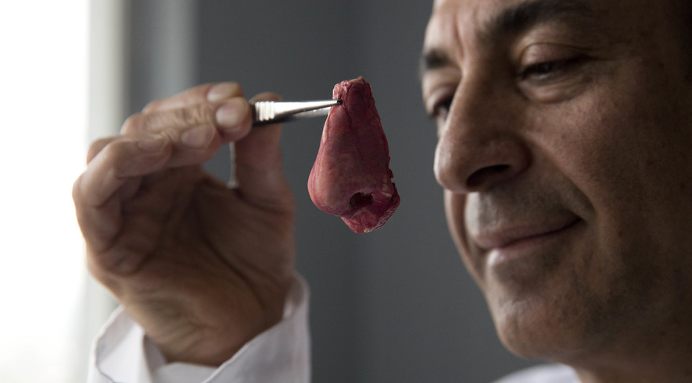
Professor Alexander Seifalian holds a synthetic polymer nose at his research facility in the Royal Free Hospital in London, March 31, 2014. In a north London hospital, scientists are growing noses, ears and blood vessels in the laboratory in a bold attempt to make body parts using stem cells.
LONDON — In a north London hospital, scientists are growing noses, ears and blood vessels in a bold attempt to make body parts in the laboratory.
Labs worldwide are pursuing the futuristic idea of growing organs for transplant. Mayor Boris Johnson showcased the London work as he announced a plan to attract more labs to do cutting-edge health and science research in the area.
So far, only a handful of patients have received the London-made body parts, including tear ducts, blood vessels and windpipes. Researchers hope to be able to transplant even more body parts soon. One of the researchers' goals is to transplant the world's first nose made from stem cells. These are cells in the body that can be made into blood cells or skin cells.
"It's like making a cake," said Alexander Seifalian at University College London, the scientist leading the effort. "We just use a different kind of oven."

Molding A Nose
Britain has invested nearly $6.7 million to jump-start research in the London-Oxford-Cambridge area. The country aims to attract companies to the area to foster collaboration and promote research and manufacturing. A major center for biological research will open in London next year.
University College London is a partner in the campaign. During a recent visit to his lab there, Seifalian showed off a sophisticated machine used to make molds for various organs from a material made from a chemical mixture called a polymer.
Last year, Seifalian and his team used that polymer material to mold a nose for a British man who had lost his to cancer. They added a salt and sugar solution to the mold to mimic the somewhat sponge-like texture of a natural nose. Stem cells were taken from the patient's fat and grown in the lab for two weeks before being used to cover the nose framework. Later, the nose was implanted into the man's forearm so that skin would grow to cover it.
Seifalian said he and his team are waiting for approval from regulatory authorities to transfer the nose onto the patient's face. They couldn't say when that might happen.
The material Seifalian uses for the organs has been patented, so other scientists cannot copy it without permission. He's also applied for patents for the lab's blood vessels, tear ducts and windpipes.
The team is creating other body parts including coronary arteries and ears. People born without ears will test the lab-made ones later this year in India and London.

Ears Are Trickier
Ears are harder to make than noses, according to Dr. Michelle Griffin, a plastic surgeon who has made dozens of ears and noses in Seifalian's lab. She says it's tricky to copy all the ear's lines and curves.
Today children who need new ears must undergo invasive surgery, says Griffin. The operation involves taking cartilage from their ribs. Cartilage is elastic tissue covering the skeleton that turns to bone later in life. She added that the team plans to create an entirely synthetic face, but must first prove their polymer frameworks won't accidentally burst out of the skin.
"Scientists have to get things like noses and ears right before we can move onto something like a kidney, lungs or a liver, which is much more complicated," said Eileen Gentleman, a stem cell expert at King's College London. She is not involved in Seifalian's research. She says the fact that Seifalian has created a functional windpipe and other body parts is "pretty amazing."
Some scientists predict certain lab-made organs will soon cease to be experimental.
"I'm convinced engineered organs are going to be on the market soon," said Suchitra Sumitran-Holgersson, a professor of transplantation biology at the University of Gothenburg in Sweden. She has transferred lab-made blood vessels into a handful of patients, and plans to offer them more widely by 2016, pending regulatory approval.
Seifalian hopes lab-made organs will one day be available for a few hundred dollars. Different sized noses could be manufactured so that surgeons could choose the size and then tailor it to their patients. "People think your nose is very individual and personal but this is something that we could mass produce like in a factory one day."
Quiz
- Why did Seifalian implant the lab-grown nose on the patient’s forearm instead of his face?
  - The patent for using blood vessels grown in the lab is still pending.
  - The procedure was not yet patented by regulatory authorities.
  - The nose was not fully grown to be implanted onto the face.
  - The nose was created using stem cells from the patient’s fat.
- Select the paragraph from “Ears are Trickier” that discusses that the making of noses in labs is paving way for making more complex body parts. Write “#2” by this paragraph.
- Which of the following DOES NOT support the central idea of the text?
  - Labs worldwide are pursuing the futuristic idea of growing organs for transplant.
  - One of the researchers’ goals is to transplant the world’s first nose make from stem cells.
  - Britain has invested nearly $6.7 million to jump-start research in the London-Oxford-Cambridge area.
  - People born without ears will test the lab-made ones later this year in India and London.
- Select the sentence that is MOST important to include in a summary of the article.
  - “It’s like making a cake,” said Alexander Seifalian at University College London, the scientist leading the effort. “We just use a different kind of oven.”
  - University College London is a partner in the campaign.
  - The team is creating other body parts including coronary arteries and ears.
  - Ears are harder to make than noses, according to Dr. Michelle Griffin, a plastic surgeon who has made dozens of ears and noses in Seifalian’s lab.
Summary: Remember to include the author and title of the article in the first sentence. You also need to include textual evidence and all the main points of the article.
__________________________________________________________________________________________________________________________________________________________________________________________________________________________________________________________________________________________________________________________________________________________________________________________________________________________________________________________________________________________________________________________________________________________________________________________________________________________________________________________________________________________________________________________________________________________________________________________________________________________________________________________________________________________________________________________________________________________________________________________________________________________________________________________________________________________________________________________________________________________________________________________________________________________________________________________________________________________________________________________________________________________________________________________________________________________________________________________________________________________________________________________________________________________________________________________

